

Consulting Report:

INSAID TELECOM

Group No. 1010

Date of Submission: July 24th

Table of Contents

1. Introduction 3

2. Project Description 3

3. Problem Analysis 3

4. Sources of Data 3

5. Challenges with the data 4

6. Data Analysis 4

6.1 Distribution of users across the 4 important variants 4

6.2 Distribution of Phone brands across 3 variants 5

6.3 Distribution of Users across various age groups 6

6.4 Gender distribution across states 7

6.5 User activity 8

6.6 Hourly Distribution of Phone Calls 9

6.7 City and State wise distribution 10

7. Analysis Summary 11

8. Recommendations for Insaid Telecom 12

9. Conclusion 13

# Introduction

INSAID Telecom, one of the leading telecom players in India is in fiercely competitive market. As such it needs to tailor its offerings to better attract and retain customers.

# Project Description

With a subscriber base of 1,206.22 million, as of March 2018, India accounted for the 2nd largest telecom network in the world. It is also one of the most competitive markets with low ARPUs and one of the lowest data charges in the world. Availability of affordable smartphones and lower rates are expected to drive growth in the Indian telecom industry.

In addition, the 1 billion+ population (the majority of which was hitherto disconnected from the online sphere) represents a monumental untapped market for the telecom sector. By 2025, the country is projected to have  [850 million new online users](https://www.consultancy.in/news/85/india-to-have-850-million-online-users-by-2025-finds-bcg), according to management consultancy [BCG](https://www.consultancy.in/firms/boston-consulting-group).

Hence it is of the utmost importance for companies to tailor their offering to clients’ requirements and to differentiate themselves from the competition in order to gain the maximum market share.

# Problem Analysis

INSAID Telecom wishes to leverage and utilise the data available to it to provide a better offering to the customers.

It has data pertaining to 9363 (unique device Ids) across 6 states (Tamilnadu, Uttar Pradesh, Manipur, Chandigarh, Tripura, Arunachal Pradesh) in India, including their age, gender, and the phone brands they prefer to use. It also has some behavioural data on these users including the frequency and timing of their voice usage.

In addition to finding out salient features of this dataset, the client has entrusted us to provide an answer to the following key questions in order to come up with key insights to increase its market share:

1. Which age group forms the biggest customer segment for INSAID Telecom?
2. Is there any difference in customer age segments in the two biggest states?
3. What are the preferred call timings for the younger generation?
4. Is the any preferred phone brand for Female consumers?
5. Is there any preferred brand across states?
6. Are there any differences in usage between metro and non-metro consumers?

# Sources of Data

The client provided the data in three separate sets. There was csv file with event specific data (each activity performed by a Device) and two SQL databases. The Events file had details of the voice calls made by each device along with the latitude, longitude, city of origin and the corresponding state. The SQL files had data on the gender, age and brands associated with each device ID. These files were then assimilated.

# Challenges with the data

1. The data sets had to be combined using the device IDs column which was a common field in all three data sets
2. The states data was missing for some events. To fill the missing values the state value of the city was found using mode of state of the particular city.
3. The latitude – longitude data was missing for some of the events which was filled using the mode of the city’s latitude longitude and one particular latitude longitude belonging to city Kadi was falsely reported as Uttar Pradesh. So that data was excluded from analysis
4. The latitude longitude – longitude data was wrong for some cities which was corrected using latitude and longitude city value
5. Phone brands and models were not in English font
6. 453 Device ID’s (approx. 0.01%) were missing in the dataset which was updated using mode of longitude and latitude
7. States focused on for analysis amounts to 534462 data points

# Data Analysis

In this data analysis, we have tried answering some of the key client queries, in addition to the basic analysis done on the data. Some of the preliminary analysis is as follows:

# 6.1 Distribution of users across the 4 important variants

|  |  |  |
| --- | --- | --- |
| Sr. No. | Factors Analysed | Observations |
| 1. | Gender | Male users are more by 25% than Female users |
| 2. | Age Segment | Individuals between age 20 to 40 years contribute to 76.4% market share |
| 3. | States | Only 2 states, i.e. Tamilnadu & Uttar Pradesh dominate the market with 98.6% share |
| 4. | Phone Brands | Top 3 Phone Brands contributing to 76% market share are Samsung, Xiomi & Huawei followed by Vivo & Oppo contributing to next 15.45% |

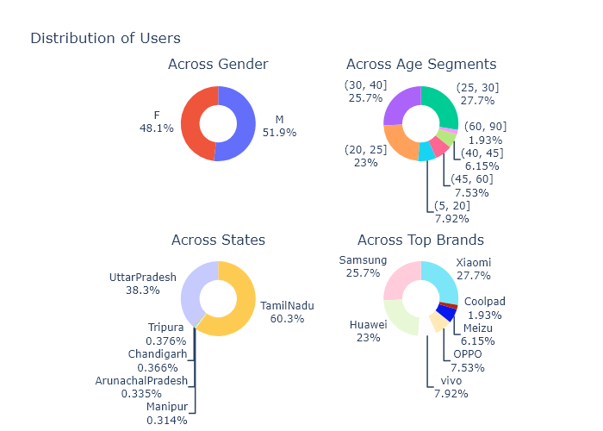

# 6.2 Distribution of Phone brands across 3 variants

|  |  |  |
| --- | --- | --- |
| Sr. No. | Factors Analysed | Observations |
| 1. | Gender | Top 3 phone brands, Xiomi, Samsung and Huawei are same across both the genders |
| 2. | States | Top 3 phone brands, Xiomi, Samsung and Huawei are same across the dominant 2 states Tamilnadu & Uttar Pradesh |
| 3. | Age Segment | Top 3 phone brands, Xiomi, Samsung and Huawei remain same across all age groups |

***Note:*** *Tamilnadu and UttarPradesh have higher market share compared to other 4 states (Manipur, Chandigarh, Arunachal Pradesh and Tripura). Hence the graphs have been plotted in 2 different groups.*

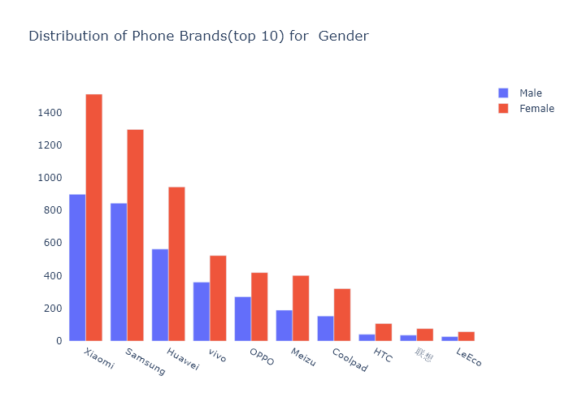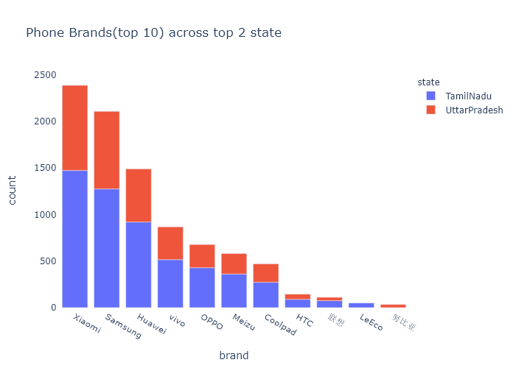

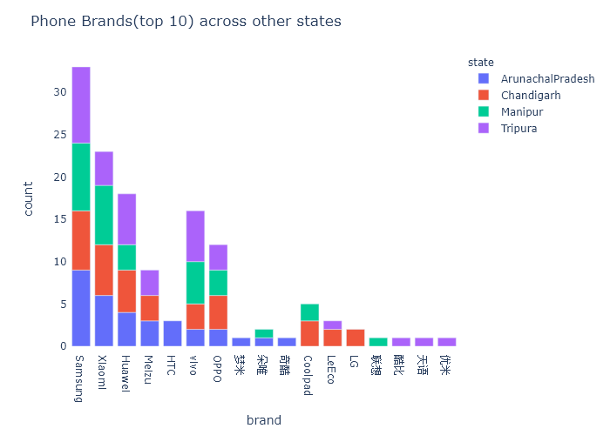

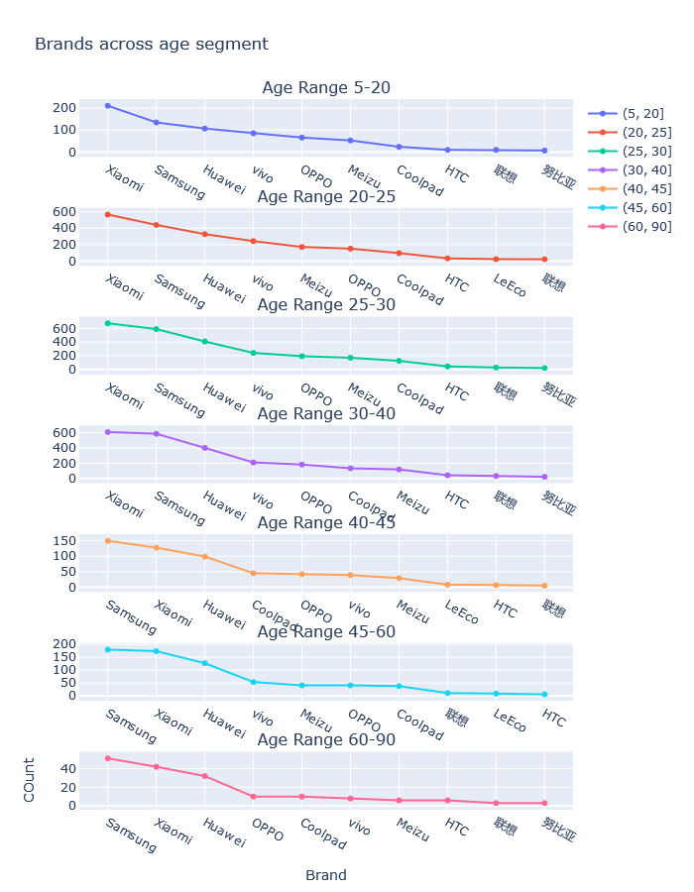

# 6.3 Distribution of Users across various age groups

|  |  |  |
| --- | --- | --- |
| Sr. No. | Factors Analysed | Observations |
| 1. | Gender | Male users are more in all age segments |
| 2. | State | 25-30 age segment is top across all state |

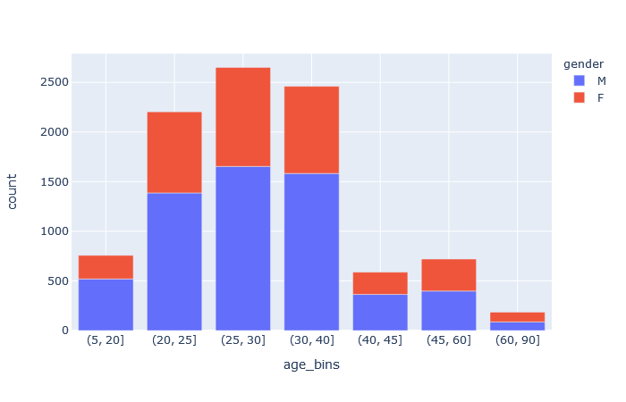

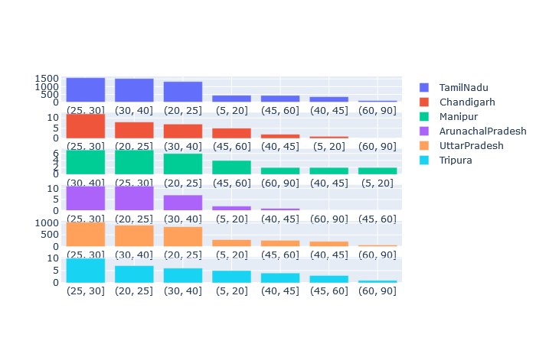

# 6.4 Gender distribution across states

Irrespective of the states the Males are dominating the market as compared to females

|  |  |
| --- | --- |
| Top 2 states (98.6% Market Share) | Other States (1.4% Market share) |

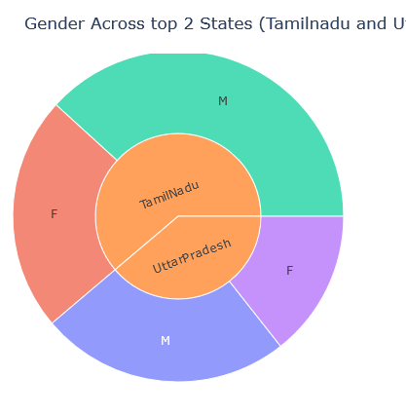 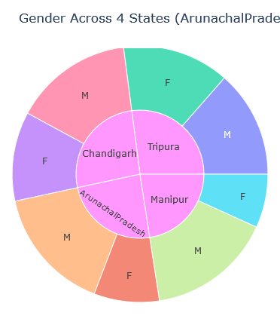

# 6.5 User activity

Activity of users were analysed from the number of calls made by users.

|  |  |  |
| --- | --- | --- |
| Sr. No. | Factors Analysed | Observations |
| 1. | Gender | Male users have more activities |
| 2. | Age Segment | 30-40 age segment is more active among all the age segments |

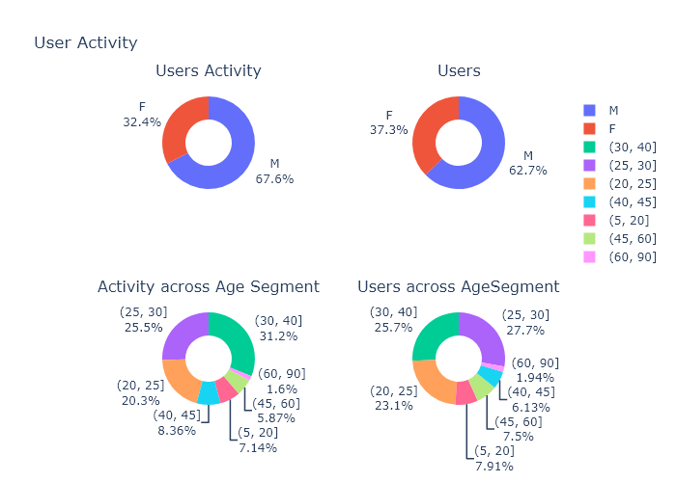

# 6.6 Hourly Distribution of Phone Calls

At an overall level, the bandwidth is under utilized during 3am to 5am and is utilized to its full capacity from 8pm to 12 midnight

|  |  |  |
| --- | --- | --- |
| Sr. No. | Factors Analysed | Observations |
| 1. | Gender | The usage pattern across the day is same for Male and Female |
| 2. | States | There is no significant difference in the hourly pattern for the top 2 states dominating the market share |

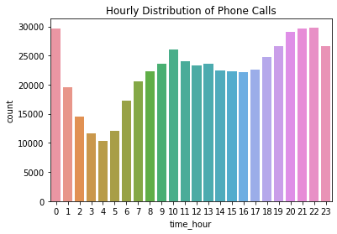

|  |  |
| --- | --- |
| Top state (98.6% Market Share) - Male | Top state (1.4% Market share) - Female |

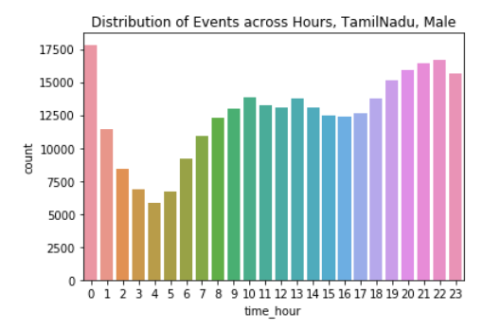 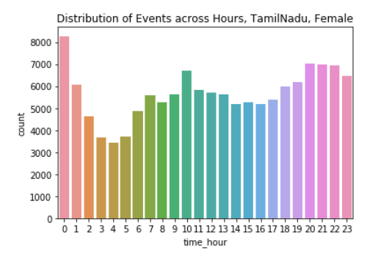

# 6.7 City and State wise distribution

* In Tamil Nadu, Chennai contributes to more than 75% of users and the user contribution is equal across 9 cities in Uttar Pradesh
* In other states the INSAID Telecom reach is only in 1 city per state

|  |  |
| --- | --- |
| Top 2 states (98.6% Market Share) | Other States (1.4% Market share) |

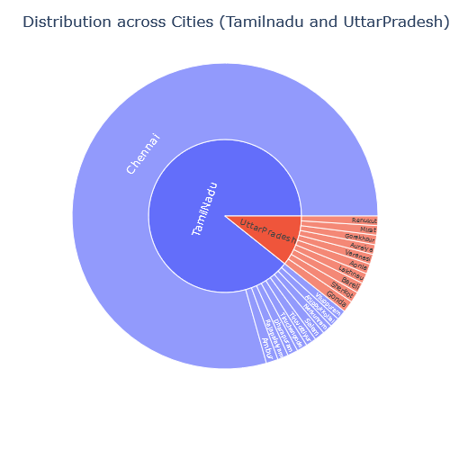 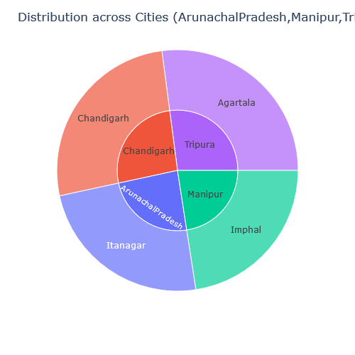

|  |
| --- |
| Overview of users across States |

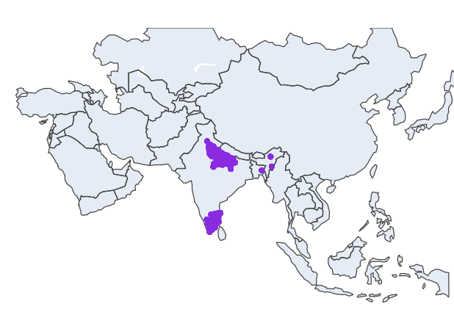

# Analysis Summary

|  |  |  |
| --- | --- | --- |
| Sr. No. | Factors Analysed | Observations |
| 1. | Gender | * Male users are more by 25% than Female users * Across all age groups Male users are more than Females |
| 2. | States | * Only 2 states, Tamilnadu & Uttar Pradesh dominate the market with 98.6% share |
| 3. | Age Segment | * Individuals between age 20 to 40 years contribute to 76.4% market share * Across all age groups Male users are more than Females |
| 4. | Phone Brand | * Top 3 Phone Brands contributing to 76% market share are Samsung, Xiomi & Huawei followed by Vivo & Oppo contributing to next 15.45% * Top 3 brands are same irrespective of the State, Gender and Age group |
| 5. | City | * In Tamil Nadu, Chennai contributes to more than 75% of users and the user contribution is equal across 9 cities in Uttar Pradesh. * In other states the INSAID Telecom reach is only in 1 city per state |
| 6. | Hour of the day | * At an overall level, the bandwidth is under-utilized during 3am to 5am and is utilized to its full capacity from 8pm to 12 midnight * The hourly usage pattern remains same across both genders and across both the dominating states – Tamilnadu & Uttar Pradesh |
| 7. | User Activity | * Male users have more activities * 30-40 age segment is more active among all the age segments |

# Recommendations for Insaid Telecom

1. **Hourly call pattern, Daily call pattern**
   1. This can be further divided to particular state and gender
   2. Free Talk time at particular hours (2a.m – 5a.m) can be given and discounts based on genders for the periods where there is less usage, to increase the usage.
2. **Phone Brand Usage**
   1. We can analyse the brand usage across states and genders
   2. The offers can be given by various brands in relevant states and for genders where there are less usage
3. **Distribution across state**
   1. There is a lot of untapped potential in various tier 2 states. The reach of mobile is very less in these areas. Marketing activities in the states of Manipur, Tripura, Arunachal Pradesh and Chandigarh has to be carried out
   2. We need competitor data for reach of telecom providers in these areas and call needs to be taken
   3. Even in state like UP there is a lot of scope to reach tier 2 cities
   4. In Tamilnadu other than Chennai though the reach is more, subscribers are less
   5. States other than Tamilnadu and Uttar Pradesh have the reach in only 1 city
   6. Other cities have to be targeted or the operations can be dropped from these states and save cost.
   7. Marketing activity can be taken up in UP and Tamilnadu for tier2 cities.
4. **Age Segment**
   1. Consumers are more in the age bracket 20 to 35. This age group has to be targeted in the tier2 states through outreach programs tying up with corporates and college students can be targeted by giving discount or devices at lower prices

# Conclusion

There a lot of untapped potential across the geography of India. Marketing activities should be tailored according to the need across different states and launch of the network can be done in the various areas which remains untouched as there is lot of scope available.